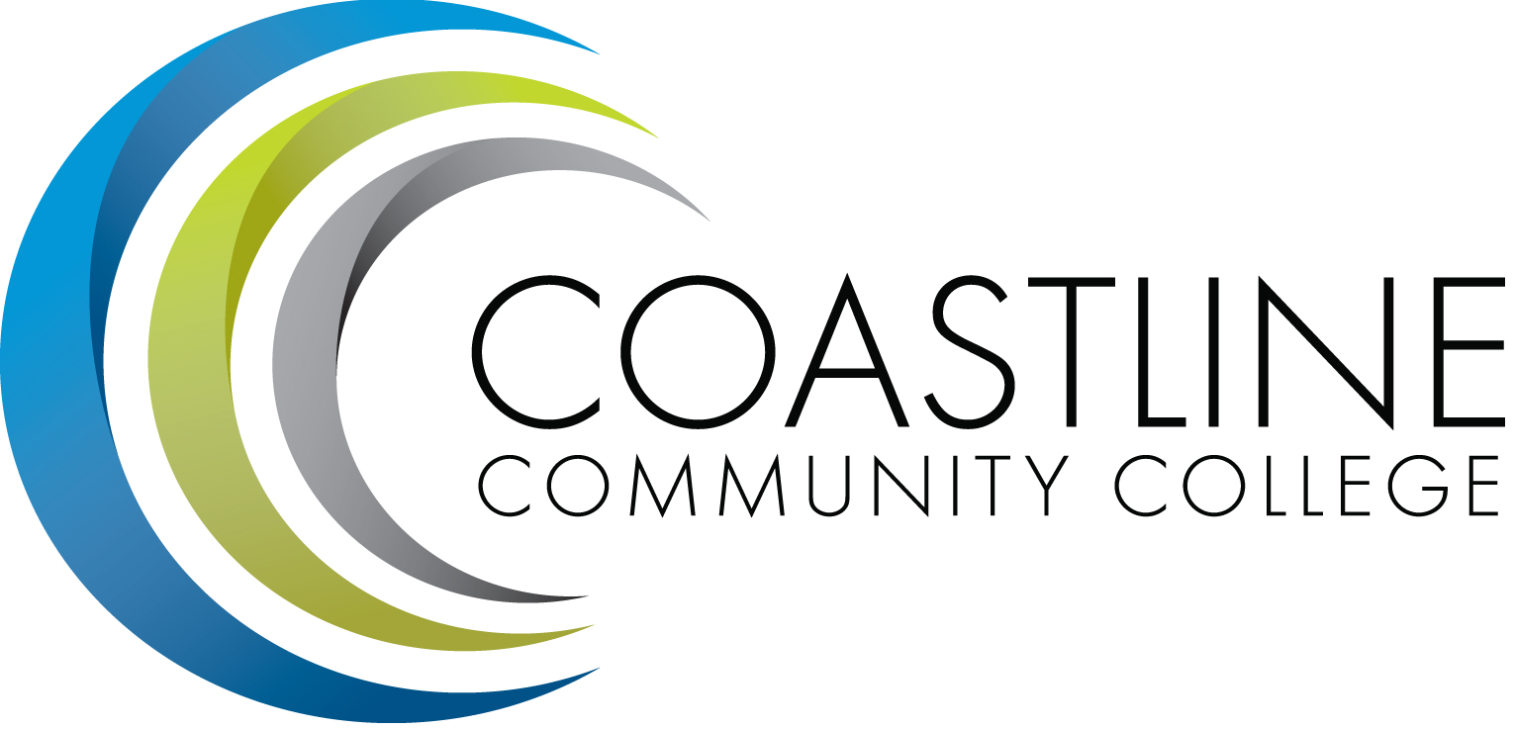

Technology Committee Meeting (TCM) 2017-2018
Thursday, April 19, 2018
3:00 p.m. – 5:00 p.m.
College Center – Fourth Floor Conference Room

MINUTES

Name | Present
Amito’elau, Sylvia | X
Blair, Shelly | EXC
Chapman, Cheryl | X
Emerson, Dana | ABS
Gonzalez, Shanon | X
Harrison, Nate | EXC
Horan, Elizabeth | EXC
Johnston, Chris | ABS
Jones, Nancy | ABS
Nash, Bob | ABS
Nguyen, Son | ABS
Thompson, Dave | X
Tran, Toan | X
Winterbourne, Susan | EXC
Guest(s): Meg Yanalunas, Instructional Technologies Designer
Christine Nguyen

Recorded: by Martha Tran-Nguyen
Transcriber: Kathleen Surgenor

CALL TO ORDER
  - Welcome – Dave Thompson opened the meeting and welcomed the committee.
  - Adoption of Agenda: Cheryl and Sylvia made a motion to approve Agenda. MSU
  - Approval of Minutes:
- 02/22/18 – Cheryl accept made a motion to approve Minutes, Toan (second). MSC

REPORTS
  - Upcoming network outage – D. Thompson – Ralph will present at the next CCC Academic Senate 5/1/18. Financial Aid needs to be done by June 2018. Dave reviewed the “Socializing” document written by Ralph.
Recommendations:
Option 1: On 6/30/18 outage through 5pm. Maybe sporadic outages through July 4, 2018, but more likely to be completed by Sunday 7/1/18 at midnight. Christine mentioned that is a very busy week for closing out the books in the Business office. Sporadic and intermittent outages may occur on 7/2-7/4/18.
Option 2: On 8/18/18 from 5pm through midnight 8/19/18 was an option but there was a concern with registration occurring this time which would cause too much disruption. Services that will not be affected are student email and Canvas.
2.2 Migrating email to Cloud – D. Thompson – discussions made on the process of migrating the exchange server moved outside of the district network. Move to request District IT to delete all email boxes not opened within 3 years. (3400 email boxes); 2 years (3200) and 1 year (3100). District will look at the list of email boxes that have not been opened for 3 years. Alias emails that are forwarded to email inboxes are checked with your regularly used daily emails. There is currently a process for the district to delete emails of people who have left the district. The email boxes that will be deleted will still be archived.
2.3 Application streaming – D. Thompson– Goal of Virtualization – first goal is to move desktops to VDI units. Applications ran on these desktops are powered at the District. Dave said he saw an app called “one campus”, utilizes the icons for apps. He said he will propose this with District IT.

DISCUSSION
  - Technology Master Plan – D. Thompson – thanked everyone for reviewing and contributing to the master plan. Version 3.0 of the Technology Master plan was sent out last week. Dave reviewed the purpose of the Master Plan. Dave would like to get the committee to approve the Technology Plan before Summer 2018. Dave will email the committee the most updated Technology Master Plan, review and be prepared to vote next meeting in May 17, 2018. Dave asked if we can go to a 2-year plan so we can follow the same cycle as the rest of the plans in the college. These plans end at 2020.
- Purpose of Plan – Approved
- District part of the Plan – ok
- Tech committee overview – ok
- Technology committee mission – created by Chris Blackmore who put it in the previous Master Plan.
- Accreditation standards – approved
- TCI 1 – The committee approved and edited TCI 1-9.
- Dave will review the plan and take out the ”&” and replace them with “and”.

ACTION ITEMS
  - Follow up on Action Items from 02/22/18:
    - Provide a full list of District IT’s definition of support software for students and staff – Dave Thompson – Dave reported that the list consists of Microsoft Office and Adobe Creative Cloud. Other programs would be obtained by purchasing additional licenses. Questions about the software programs should be submitted to IT via a Help Desk Request. Dave and the committee discussed various software programs that are and are not currently supported by District IT. Dave will provide a list of software programs currently supported by District IT for the committee’s review. Dave will create a separate list of Coastline software programs supported by IT. Ongoing - Dave will share 2 lists with the committee.

We will revisit the above action items in the Fall semester meetings. Our priority right now is to complete the Technology Master Plan.

STANDING REPORTS
  - District IT Directors Meeting – Dave Thompson – Discussions were made about Voice-over IP and our position. District has $7 million and will determine how it will be split. This will be put into the CAM unit. The question was whether we can get the funds from the District before it is distributed in the funding model. The copper wiring is old (over 35 years old).
  - District Technology Meeting – Dave Thompson – Cheryl said Board Approved Tech Smith and then Ralph presented on the above reports in 2.1
  - PIEAC – Dave Thompson – Marketing department plan was presented by Dawn Willson.
  - Academic Senate/FSC – Cheryl Chapman – Kate Mueller gave overview of Financial Aid Fraud situation. There is a fraud ring of 25 students. Gave a handout of how to deal with situations like this at our own campus. FSC coordinator position was approved and Guided Pathways coordinator position.
  - Associated Government – no ASG rep attends meetings.
  - Classified Senate – no representation, no report.
  - Canvas Work Group – Sylvia A – Canvas meeting was held on March 20, 2018 meeting – they will be working on the syllabus export tool. Help tickets was discussed, higher than usual of students encountering bad links as instructors not correctly entering content. Canvas has a link validator and FSC is reminding faculty to use the link validator. Canvas training for Classified staff will be at the May 4, 2018 professional development day. Canvas Summer shells are in for Coastline. SLOs were loaded from Banner into Canvas shells. District IT has assumed all responsibility and middleware for Banner.
The next Canvas meeting is 5/1/18 at 10:00am in the Annex Conference Room. Everyone is welcome.

ANNOUNCEMENTS

SUMMARY OF KEY ITEMS DISCUSSED/ACTIONS TAKEN
  - Technology Master Plan

ADJOURNMENT
The meeting was adjourned at: 5:00 p.m.

Next Meeting: Thursday, May 17, 2018, 3:00-5:00 p.m., 4th Floor Conference Room
*Attachment emailed
**Attachment provided at meeting

